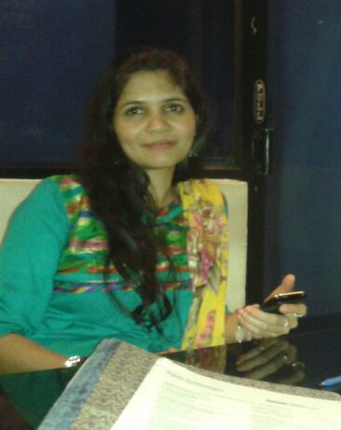
QUALIFICATIONS PROFILE
Technically sophisticated and dedicated professional having more than 12 years of experience in Business Development, Administration, Client Relationship, Marketing and merchandising.

Possess remarkable leadership experience to effect dramatic improvements in efficiency, productivity, and business processes toward successful attainment of company goals.

Well-versed in developing cross-functional team members while maintaining high ethical and quality standards, professional demeanor. Known for a keen eye for detail and capability to multitask in fiercely competitive and fast-paced environment.
CORE STRENGTHS

- Administration  - Delivery and Quality Management | - New Business and Strategies Development
- People Management | - Continuous Process and Productivity Improvement
- Problem Resolution and Decision Making | - Technical Support and Troubleshooting
- Leadership, Training, and Team Building | - Outstanding Customer Service and Relations
- Articulate Oral and Written Communication

EMPLOYMENT HISTORY

Jan 2014 :

Working with a Life Insurance MNC as Recruitment Manager recruiting Financial advisors, looking into the sales and client service.

Feb 2013 till JAN 2014:

Working in Times Technologies as Administration Manager.

Responsible for:
- Managing end to end prospect of business development activities
- Responsible for General administration, Counseling, relationship management and Employee management.
- Effectively managing by distributing workload appropriately, recruiting faculty and developing skills necessary for the organization.
- Preparation of bonus, overtime , Salary Arrears & Income Expense Statement,
- Tracking Budget Expenses, Quality Management, Communication Processes and Promoting Process Improvement
- Constant improvement /enhancement of course curriculum based on market trends.

Jan 2012 to Sept 2012

Business Development Executive in A.B Pinnacle Stone Pvt. Ltd .

Deals with trading & exporting of granite tiles & slabs located in Koramangala. Duties involved preparing Proforma Invoices, Purchase Orders etc, Developing new overseas markets / clients.

Sept 2003 - Dec 2010

Client Relationship Manager and Marketing Associate at Mascot Industries
- Prepared stock and sales plans together with buyers, planned product ranges, suppliers, stores, and distributors.
- Drove down delivery lead times and cost leveraging volume based freight delivery services.
- Participation in exhibitions across India winning multiple new customers and repeat business for existing customers.
- Provide inputs to global design and manufacturing team regarding market trends and designs which attracted higher audience and sales and also reduced production costs.
- Leveraging of various B2B and B2C portals for delivering and distributing raw and finished goods.
- Liaising with manufacturing unit and frequent review to ensure quality and adherence to customer requirements
- Lead a team of 4 people to handle various customer and marketing queries and resolution.
- Upgrading of production and stock maintenance software with additional features to enhance complete end to end process from enquiry to delivery.
- Responsible for dealing with Customer relevant queries, complaints and request for information on products and services.
- Assigned the tasks of processing customer orders
- Communicate effectively with teams to ensure quality and timely expedition of customer requests
- Study through the Internet new Countries where Textile products would sell well and contact the buyers, send them pictures of products & samples thus bringing interest in them for Hand woven cotton home furnishings . Making them visit India and visit the factory to show how handloom fabrics are woven and finally get an order from them.
- Setting up of display room with latest design & products aiming the buyers requirements.
- Internal Auditing
- Export Documentation
Notable Achievements:
- Preparation and presentation for International buyers regarding new designs, products. Participated in exhibitions with the latest design trends. Meetings with International clients – understanding their design concept and developing the same for them. Displaying our latest designs / products and receiving their orders.
- Provided inputs to leadership team to have a “Factory Sale” for unsold, defective goods, leading to a recovery of up to 70 % of product value.
- Was the key driver for BSCI (Business social compliance incentive) within the organization to get the certification and compliance for the organization.
April 1999 - 2000
Merchandiser - Cannanore Handloom Exports
- Provided services to the customers from different locations, developed customer contacts, wrote and executed contracts, created business opportunities, and executed other transactional activity
- Responsible for quality and timeline delivery to the customer.
- Representation of the organization in various exhibitions.

Notable Achievements:
Implemented Textile software in order to have a hassle free work movement from Enquiry stage to order delivery and payment receipt.

EDUCATION
Bachelors in Science

- 1993-1996 Calicut University, Kerala
- 1991-1993 10+2 C.B.S.E , Doha Qatar

PROFESSIONAL TRAINING & CERTIFICATIONS
Higher Diploma in software Engineering from Aptech Computer Education 1996-1998

- Certification Course in Web designing 2001-2002
- Computer knowledge: MS-Office, Oracle with developer 2000 , Unix, C, C++, OOA/D, OOP with C++ - Project done on RDBMS using Object Oriented Analysis and Design, Software Testing

